**Week 1 – Notes**

**Introduction to ML Strategy**

**Why ML Strategy**

A strategy is needed because when you want to improve the performance of your NN you can try a lot of things, but you can wander around for many months by choosing a wrong path

**Orthogonalization**

Is the process of tuning a NN by separating the techniques used, so that we don’t influence other things except the thing we are tuning

For example, an analog TV has several buttons to adjust the image, but each knob do not influence other settings

If there had been a single knob that changes every setting in a specific proportion, the process would had been harder

Exactly like that for the DL, there is a chain of assumptions

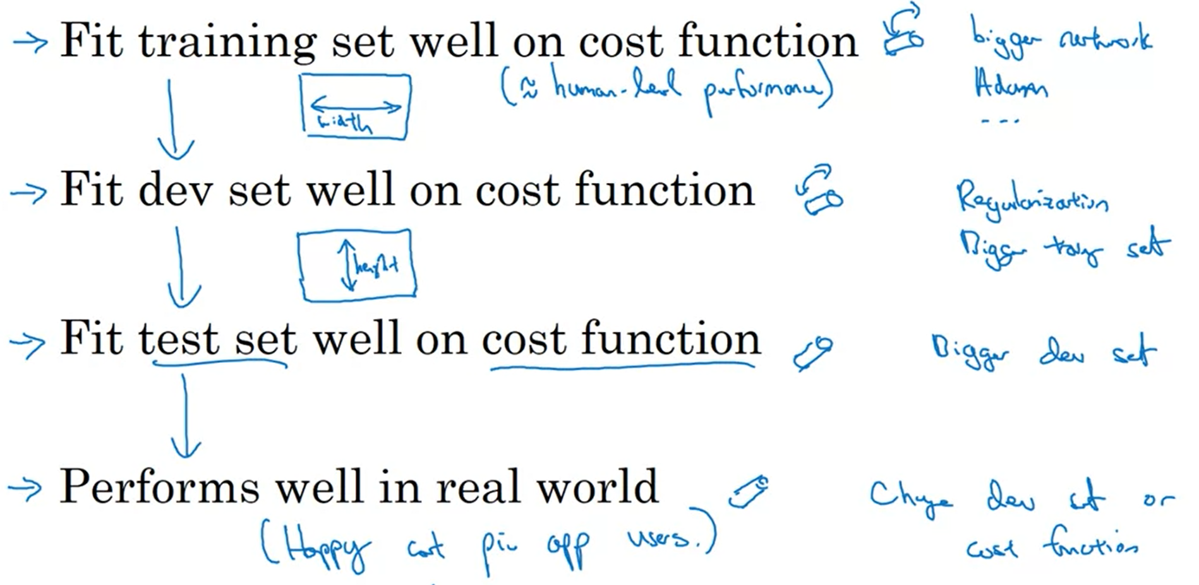

Early stopping represents a technique that interfere in the same time with the performance on the train and dev sets

**Setting Up your Goal**

**Single Number Evaluation Metric**

If you deal with a classifier for which you have computed the precision and the recall, it would be really hard to pick the best model considering multiple metrics

Precision – of the examples recognized as 1, what % actually are 1?

Recall – what % of actual 1s are correctly recognized?

It’s better to use only one metric, for example the F1 score, which is the harmonic mean of P and R

In order to evaluate a model you need a dev set and a single (real) number evaluation metric

Another example: if you have multiple models with metrics computed on different regions, pick the best model based on the mean of the performance across these regions

**Satisficing and Optimizing Metric**

You cannot optimize more metrics at once

For example, if you have several classifiers for which you measure the accuracy and the running time, only the accuracy has to be maximized and the running time to be satisfied (under one threshold)

If you have N metrics, you optimize one and you satisfy N-1

**Train/Dev/Test Distributions**

The dev set + the metric represent the target you want to hit

It’s really important to pick these 2 correctly, because otherwise, if the dev and test sets have different distributions, then you can have good results for dev, but the results on test are rubbish

Dev and test sets should be randomly picked; pick them so that they reflect the data you expect to get in the future and consider important to do well on

The training set and how you choose it affects how well you hit that target

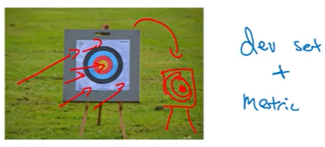

**Size of the Dev and Test Sets**

Traditionally, the dev and test sets represent a large portion for the whole data (like 30% - 40% in total) and that’s fine when you deal with small data sets (<10,000 examples)

For large data (>1,000,000 examples), it’s ok to leave only 0.1% or 1% for dev / test

The size of the test set should be big enough to give high confidence in the overall performance of your system

If you are ok with a biased estimate on the dev set, you can avoid having a test set, but if you have only 2 sets, name them train and dev, not train and test